«ALL OVER GEORGIA»
7 night / 8 days

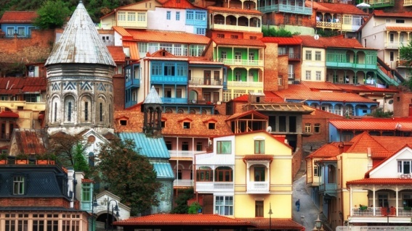
Day 1 – TBILISI
Arrival.
Transfer to the hotel located in the city center.
Dinner at the national restaurant.
Day 2 - TBILISI – MTSKHETA
Breakfast in the hotel.
Start at Holy Trinity cathedral, one of the largest orthodox cathedrals in the world. Continue to Metekhi church and monument to Vakhtang Gorgasali, the legendary founder of Tbilisi.
Take cable car to Narikala Fortress to enjoy breathtaking panoramic view of the city.
Walk down to the district of Sulphur bath houses passing by the only mosque in Tbilisi. Stroll through the Sharden area full of narrow streets with cozy cafes, wine tasting bars, souvenir shops, and breathe in the living past. Visit Sioni Cathedral, Anchiskhati Basilica, and the clock tower of famous Rezo Gabriadze Theatre.
Day 3 – KAKHETI
Breakfast in the hotel.
Departure to Kakheti.
Arrival in Tsinandali - Alexander Chavchavadze's Estate (XIX in) which includes the House museum, the famous park with unique plants and century trees, an ancient wine cellar with the most rare copies of modern and vintage wines.
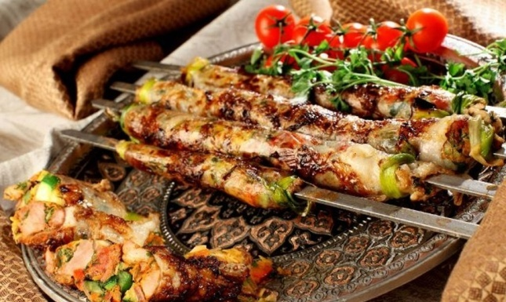
Dinner and wine tasting at the Twins Old Cellar. Check in hotel.
Travel to Mtskheta, one of the oldest towns and the cultural and religious centre of Georgia.
Mtskheta was the capital of the Eastern Georgian Kingdom of Iberia from the third century BC.
Visit Jvari Church, a true architectural masterpiece of the early Medieval Period overlooking the confluence of Aragvi and Mtkvari rivers from the top of the hill, and Svetitskhoveli , the main cathedral of Mtskheta and a sacred place where the robe of Christ is being kept.
Return to Tbilisi.
Dinner at the national restaurant.
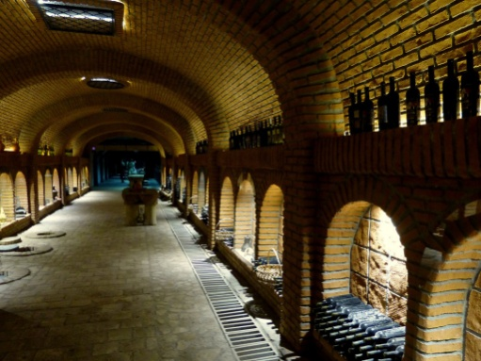
Day 4 - KAKHETI – TBILISI
Breakfast in the hotel.
Visit Signagi - This small, mid-century city Signagi is situated in Kakheti region, famous with its old wine culture. Signagi otherwise is called "city of love", as it's one of the most popular places for bride-couples. It is surrounded by defensive walls and towers. You can see church of holy Stephen built in the fortress of the town. From Signagi there is beautiful view on the Alazani valley, boundless space stretching to the horizon. Next, we look in ethnographic museum and have lunch there tasting delish Kakhetian meals and wine.
Bodbe Monastery - (built in 9th century) of Saint Nino (the saint, who preached Christianity in Georgia), which is 2 km away from Signagi. Here is the grave of Saint Nino and her holy spring - the sites visited by believers from all over the world. It is believed that anyone with strong belief, having bath in the spring, will be cured from all diseases and dreams be fulfilled.
In the evening return to Tbilisi.
Day 5 - KUTAISI – BATUMI
Breakfast in the hotel.
Travel to Kutaisi.
Gelati Monastery is unique for its mosaics and wall paintings. Gelati was a center of science and education. Academy established inside walls of Gelati complex, was one of the most important centers of culture in ancient Georgia. Gelati monastery precinct is enclosed by a stone wall, now entered from the east but originally through the south porch, which houses the tomb of its founder, David the Builder.
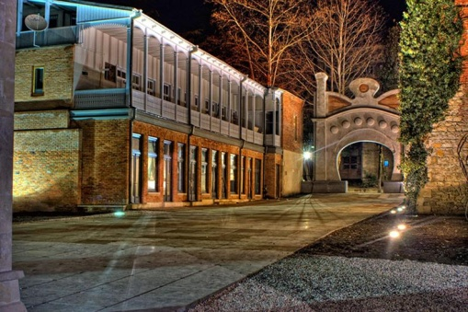 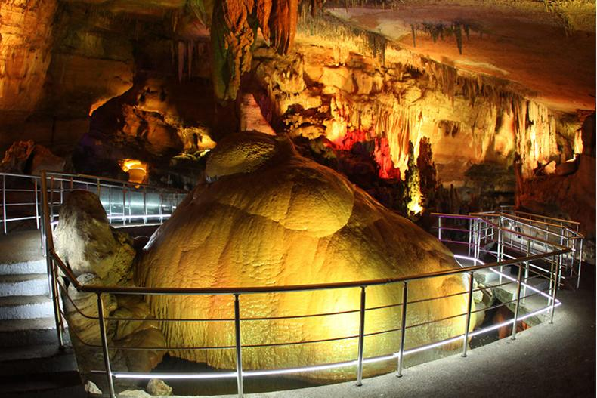 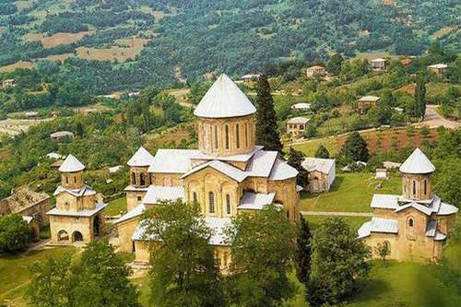
Prometheus cave is one of the richest caves of Europe. It is characterized by the variety of underground rivers and beautiful landscapes. Walking route for tourists is 1060 m. Near the main entrance about 60 meters long there is a lake . the cave itself is very breathtaking with its specious architectural halls, which are 16 of them and each one is distinct by scales and unsurpassed shape . Promete cave is one of the richest with its space, variety and underground rivers and landscape. The part of the route is passed by boat.
Travel to Batumi. Check in Hotel.
Dinner at the national restaurant.
Day 6 – BATUMI
Breakfast in the hotel.
Batumi walking tour
Visits to:
Batumi Boulevard and Musical Fountains, St. Barbara's Church, St. Nikoloz church, 6 May Park, Ajarian House, Dancing Fountains, Statue of Medea, Piazza, Batumi Sea Port, Alphabetic Tower, Moving sculpture of Ali and Nino.
Dinner at the national restaurant
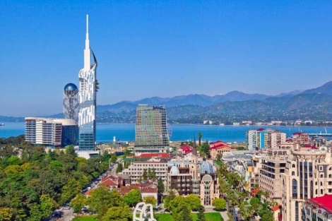 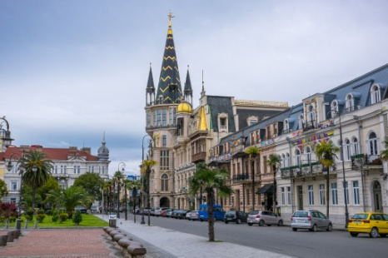 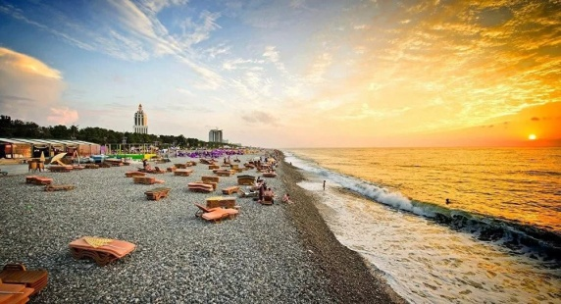
Day 7 - BATUMI – TBILISI
Breakfast in the hotel.
Visit to Batumi Botanical Garden.
Currently, the garden consists of nine floristic sectors, those of Caucasian humid subtropics, East Asia, New Zealand, South America, the Himalayas, Mexico, Australia, and of the Mediterranean. The garden collection comprises 2037 taxonomic units of ligneous plants, including 104 of Caucasian origin.
The Batumi Botanical Garden had formerly been operated by the Georgian Academy of Sciences. Since 2006, it is an independent institution.

Return to Tbilisi.
Dinner at national restaurant.
Day 8 – BATUMI
Breakfast in the hotel.
Transfer to Airport. Departure.
COST OF THE PROGRAM:
Per Person In DBL Room
 | 2 – 3 pax | 4 – 6 pax | 7 – 9 pax | 10 – 14 pax
Voyager Hotel /  Hotel Rcheuli Telavi / Hotel Iberia Batumi | 1170 | 1080 | 1045 | 985
Coste Hotel /  Royal Batoni /  Le Port Batumi | 1280 | 1190 | 1150 | 1095
MERCURE OLD TOWN /  Lopota resort /  HILTON BATUMI | 1385 | 1290 | 1255 | 1190
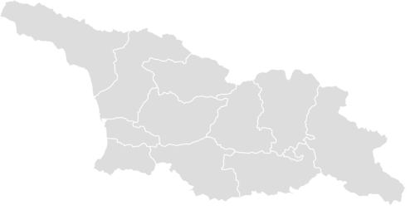
Price includes:
- Accomodation / BB
- All transfers as per itinerary;
- Englih speaking guide;
- Wine tasting ;
- Dinners at national restaurant;
- Entrance tickets;
- Mineral water (per person per day)
The price does not incl
- insurance,
- food except. breakfast, guide and driver gratuities, services not mentioned above

Туроператор «Майвэй Тревел» работает на туристическом рынке с 2011 года
номер в Федеральном Реестре Туроператоров МТ3 017248
_____________________________________________________________________________________

