Co-operation proposal of Casino Junket tour in Georgia
Location
Casino «IVERIA» is located in the hotel «RADISSON BLU» in Batumi, Georgia.
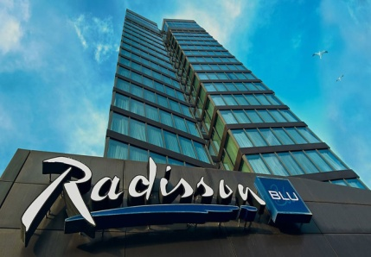 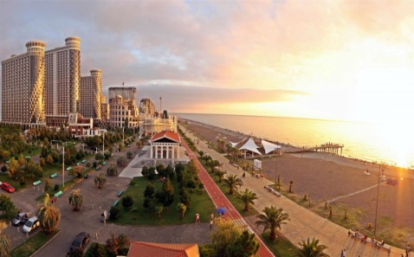 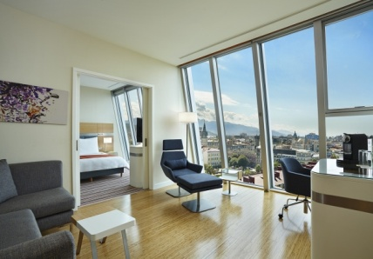
Casino is working 24 hours / 7 days a week.
There is no any dress code, but there is entrance fee on spot. Casino is providing free parking to each guest.
The minimum age of guests 21 years old. Each of them must have personal ID card or Passport.
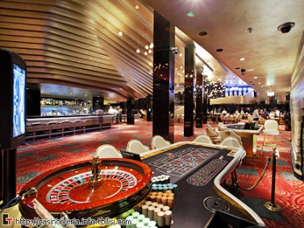 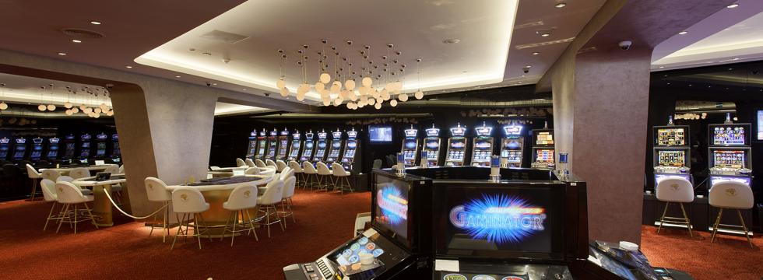 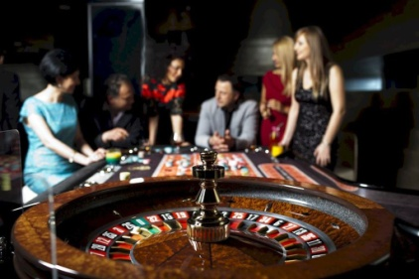
Playing machines
There are more than 130 modern playing machines in the gaming room with more than 100 kinds of games. Each machine is different in interface, rules and minimum betting amount.
Playing machines:
-Premium-V + Germinator (1-2-4-5)
-Novo line Interactive (1-2-3)
-Magic Games Premium HDVIPIII
-Super-V+Gaminator (44-61-64-66)
-Premium-V+Gaminator
-Vega Vision (Multi 5,6,7)
-Vega Vision (Premium Multi 3-4-5)
- Roulette GPB Gambee
-Lotus Roulette
Table games
Casino «IVERIA» is offer in the most popular choice of table games such as:
-Blackjack
-America Roulette
- Poker:
Poker (6 cards)
Poker (Texas holder)
Poker (Russian)

- Confidential information -
Our Company offers to organize junket tour with the following conditions:
1. Planning the Junket tour for the groups in Batumi including accommodation in the hotel
«RADISSONBLU» with 50% of discount on Bed & Breakfast bases;
2. Minimum group: not less than 5 persons;
3. Minimum chips order not less than 3000$
(This is a must to receive 50% discount on accommodation)
5. Minimum playing time: Not less than 4 hours;
6. Free transfer from airport to the hotel and back;
7. Free meals and drinks in casino;

We have special offers for casino-tours in Tbilisi
«RADISSON BLU» !!!

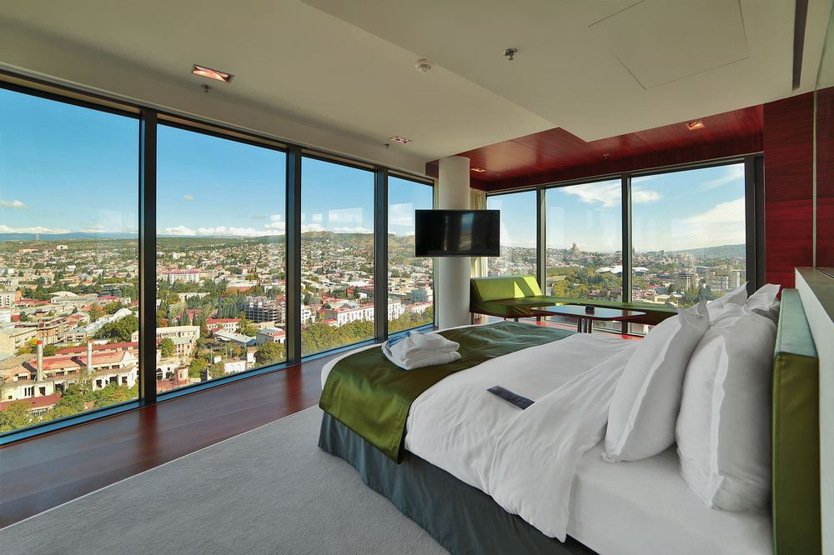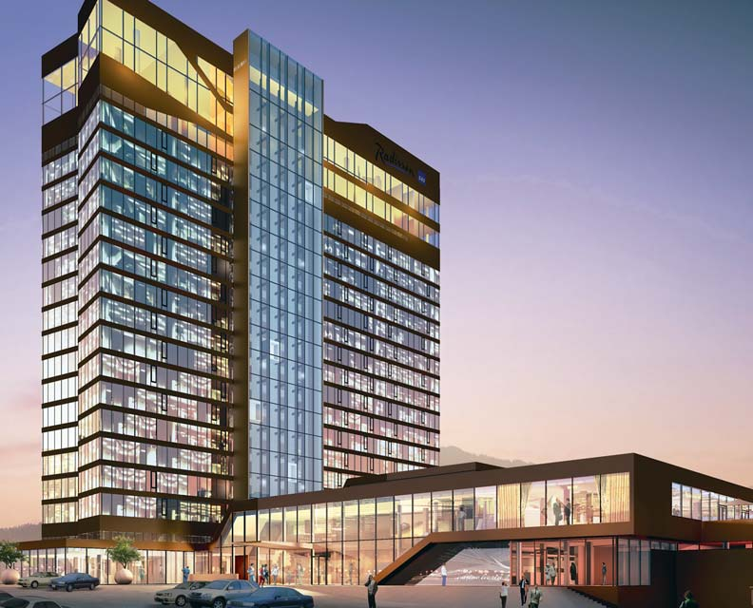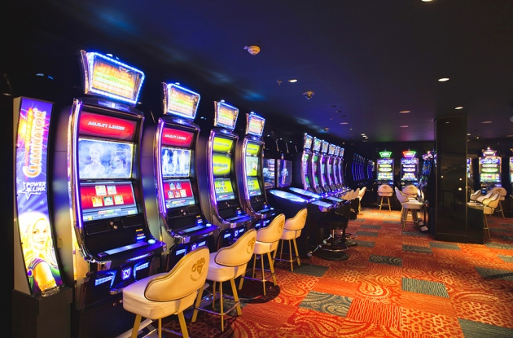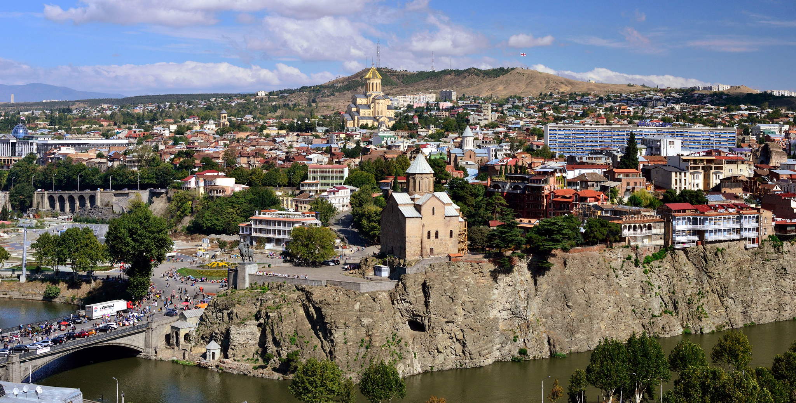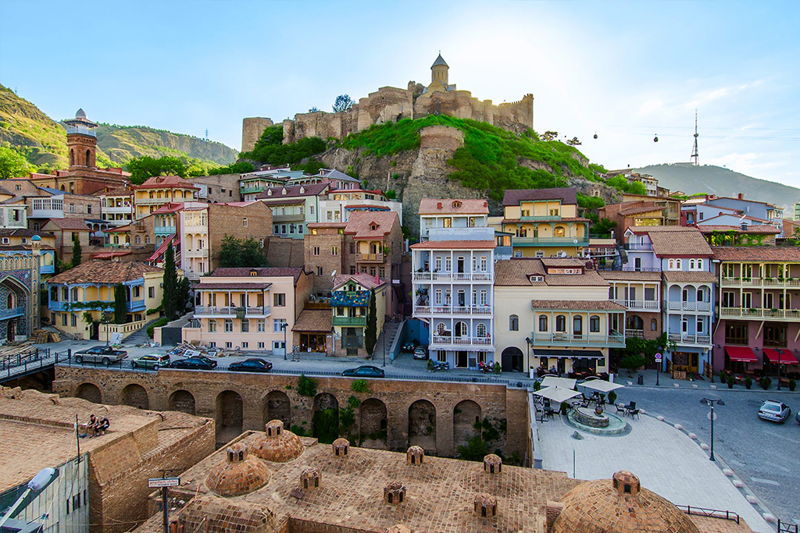

Туроператор «Майвэй Тревел» работает на туристическом рынке с 2011 года
номер в Федеральном Реестре Туроператоров МТ3 017248
_____________________________________________________________________________________

