«Cultural Tour in Georgia»
3 nights/ 4 days
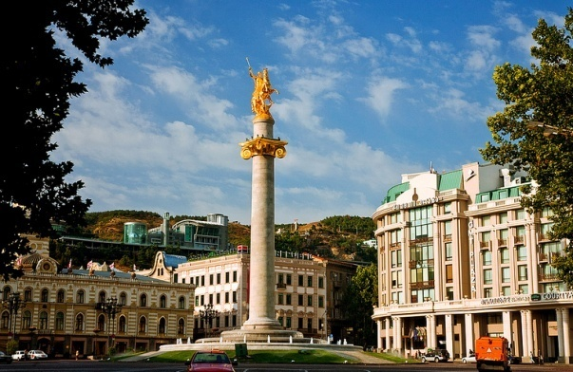
Day 1 - Arrival
Meeting at Tbilisi international airport
Transfer / Accommodation.
Overnight at the hotel in Tbilisi.
Dinner at the restaurant with Georgian national dances and songs.

Day 2 - Tbilisi City Tour
Breakfast at the hotel
Metekhi (12th c.) - cross-domed church;
Sulphur baths - a favourite place of Tbilisi citizens and foreign guests (A. Pushkin, A. Duma, L. Tolstoy among them);
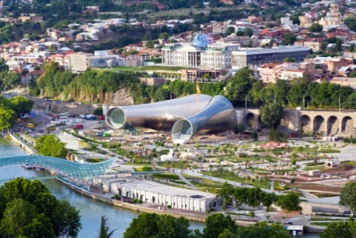 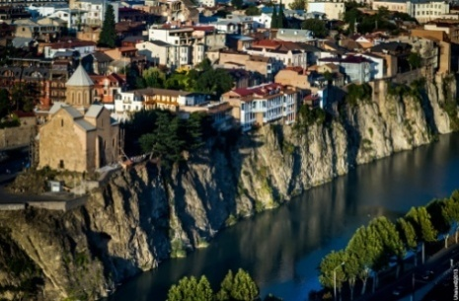 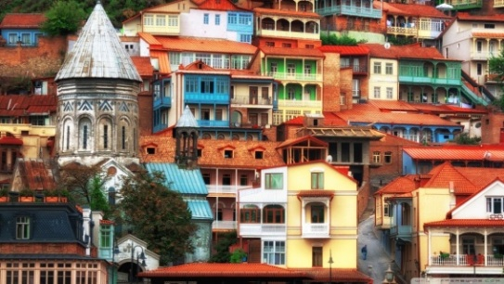
Narikala Fortress - the 4th - 20th cc main citadel of the city;
Sioni - cathedral of the 6th-7th c.
Sharden street – one of the famous and nice street in Tbilisi;
Anchiskhati (6th c.) - one of the most ancient basilica in Tbilisi;
- Mount Mtatsminda (The Holy mountain) - architectural and artistic symbol of Tbilisi, with the church of St. Father David , pantheon of famous writers and public figures, and a funicular on it’s slope
Lunch at the local restaurant with traditional Georgian dishes.
Mtskheta - Remains of towns at this location have been dated to earlier than the year 1000 BC, and Mtskheta was capital of the early Georgian Kingdom of Iberia during the 3rd century BC – 5th century AD. It was the site of early Christian activity, and the location where Christianity was proclaimed the state religion of Georgia in 317. Mtskheta still remains the headquarters of the Georgian orthodox and Apostolic Church.
Jvari Church (6th-7th cc) - cross-shaped church in plan of the early Medieval Period.
Svetitskhoveli – one of the biggest Christian temple in Georgia - was erected in the 11th c in the same place where the first Christian church in Georgia stood in the 4th c.
Overnight at the hotel in Tbilisi
Day 3 - Tbilisi – Ananuri – Kazbegi – Gudauri
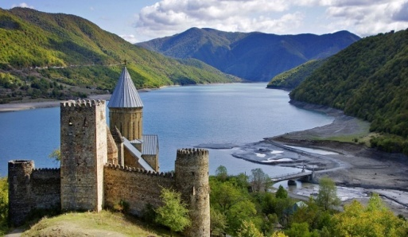
Breakfast at the hotel
Ananuri fortress - Castle on the Aragvi River in Georgia, about 45 miles from Tbilisi. The fortifications enclose, amongst other buildings, two churches. In the older Church of the Virgin are buried some of the Eristavis (dukes) of Aragvi.The Church of the Assumption, built in 1689, it has richly decorated facades, including a carved north entrance. It also contains the remains of a number of frescoes.
Lunch at the local restaurant
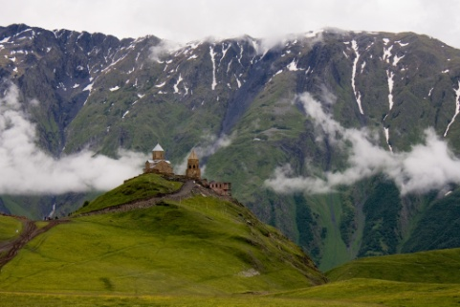
Departure to Kazbegi - mountains of the Caucasus, near to the Russian border. It is the easiest access to the Caucasus, and a popular place for a trek. It is a part of the northern slope of the Caucasus range and encompasses the Tergi, Truso and Sno river valleys. The center of the region is the village of Stepantsminda (formerly called as Kazbegi) at the foot of Mount Kazbek (5033m).
Gergeti trinity church - (14th century) with the site of mountain Kazbegi (5033m.).
Drive back to Gudauri – One of the popular and professional winter ski resort in Georgia. Overnight at the guesthouse in village Gudauri.
Day 4 - Tbilisi
Breakfast at the hotel
FREE TIME
Transfer to the Tbilisi International Airport
COST OF THE PROGRAM:
 | 2-3 pax | 4-6 pax | 7-9 pax | 10-14 pax | 15-18 pax
3*  «VOYAGER HOTEL» | 390 | 344 | 305 | 277 | 248
4*  «CRON PALACE» | 499 | 434 | 408 | 387 | 357
5*  «ROOMS TBILISI» | 588 | 528 | 498 | 468 | 438
Price includes:
- Inland transportation by car
- Excursions & entrance fees
- Accommodation on days: 1, 2, 3
- Meals / full board on days: 2 / Breakfast & lunch on day 3, 4
- 1 bottle of mineral water per person per day
- English speaking Cultural Tours Guide
Price excludes:
- Single room supplement
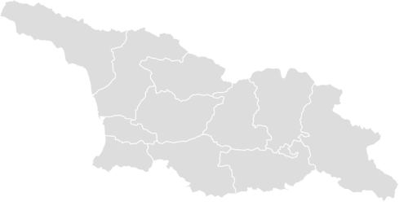
- Alcohol drinks

Туроператор «Майвэй Тревел» работает на туристическом рынке с 2011 года
номер в Федеральном Реестре Туроператоров МТ3 017248
_____________________________________________________________________________________

