«GEORGIAN DAYS»
6 nights/ 7 days

DAY 1 - TBILISI
The history of this amazing city stretches from ancient times. Namely, from the V century, when the Georgian King Vakhtang Gorgasali ordered to build a city in the center of the fertile valley, which lies snugly between two Caucasian mountain ranges. The name of the city was not accidental. It comes from the word "tbili", which means "warm". After all Sololakskoy plain between the mountain and the Metekhi cliff, where the city is located, is rich with the warm sulfur springs. Today the image of the city harmoniously combines ancient and modern features: near churches VI-VII centuries up to modern high-rise buildings, there are broad streets, parks, gardens, squares.
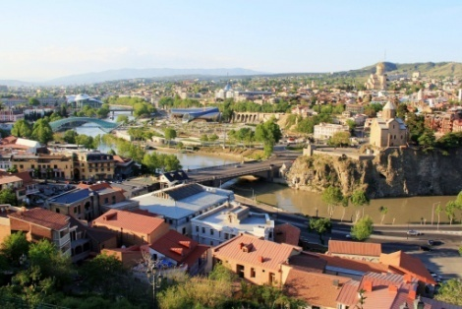
Georgia - a unique mixture of all four seasons. On the pointed tops of mountains sparkling snow, autumn fog with rain and snow reigns in the foothills, river valleys - spring flowers and fruit trees, and finally the hot summer among evergreen trees on the shore of the Black Sea.
Everyone in Georgia says about cultural richness: places of worship of the early Christianity - old churches and monasteries, lost in Caucasus mountain steeper. About the richness of nature eloquently "speaks" the unique scenery of this region. Do not even need to say about generosity of Georgian residents the phrase "Georgian hospitality" today has already become a household name, which embodies the revelry feast, where for every glass of magnificent Georgian wine is pronounced no less magnificent Georgian toast.
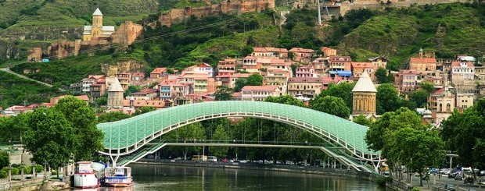
Today, Georgia still inspires thousands of tourists from around the world, which are attracted here by the beauty of nature - clean air and unique mountain ranges, beautiful lakes and healing mineral springs; holy places - the unique cultural monuments, famous hospitality.
Georgia has a huge tourism potential. The popularity of this trend is rapidly increasing the number of visitors are coming here.
In this journey we will try to show you all the best and most interesting that you can see for such a short time!
Dinner at the restaurant with Georgian national dances and songs.
Hotel accommodation.

DAY 2 - TBILISI - MTSKHETA
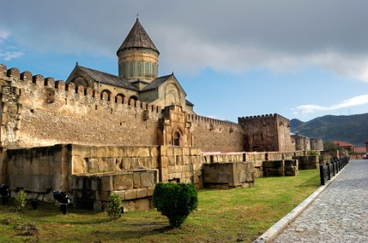
Breakfast in the hotel.
The first half of the day, we will be devoted to sightseeing tour of Tbilisi - this unique city, revived again. You can see with your own eyes ancient and modern Georgian capital. The second half of the day we will drive to the town of Mtskheta (30 km from Tbilisi), sightseeing, a visit to the monastery Jvari and Svetitskhoveli Orthodox Cathedral. Return to Tbilisi.
Return and night in Tbilisi.

DAY 3 - KAZBEGI MUNICIPALITY
Breakfast in the hotel.
Highlands, one of the few completely mountainous regions of Georgia is located great mountain Kazbek, which is widely known in Georgia with Gergeti Trinity Cathedral. There Sioni Temple in the village of Sioni. There also are 3-4 little-known temples. Recently built Archangel Monastery near the customs.
There are two fortresses - Arshi and Sno. In Russia, more aware is of the castle ruins, the known as "Tamara's Castle" from Ilf and Petrov.
As In addition to man-made, there is a lot of miraculous - the mountains. And also, there are several extinct volcanoes.
Return and Overnight in Tbilisi.

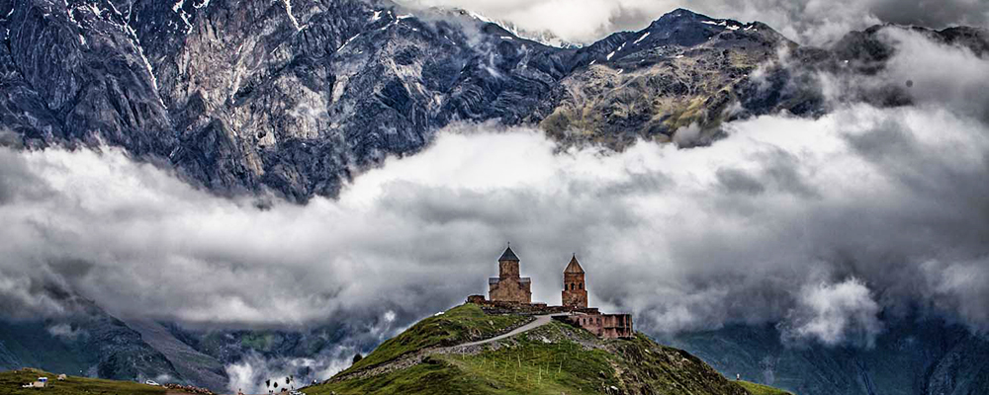

DAY 4 - BORJOMI
Breakfast in the hotel.
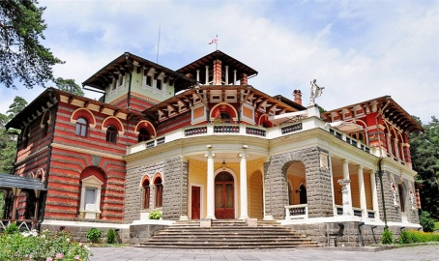
Borjomi city located in the south-eastern part of Georgia, in the gorge of the river Kura, in 152 km west of Tbilisi. For experienced eco-tourists it is not only a Soviet health resort, but also a place with a unique natural conditions, due to which we can safely say that if not the water Borjomi, Borjomi city, even though would become a favorite resort for many. This picturesque region, located in a valley surrounded by majestic massifs of the Caucasian mountains covered with broadleaved and coniferous forests, which sometimes reaches a height of 3 thousand meters above sea level. Still today Borjomi is known as a spa resort, where people come not only to rest and restore shattered hum and rhythm of city life nerves, but also the treatment of various ailments.
Overnight at the hotel Borjomi.

DAY 5 – VARDZIA
Breakfast in the hotel.
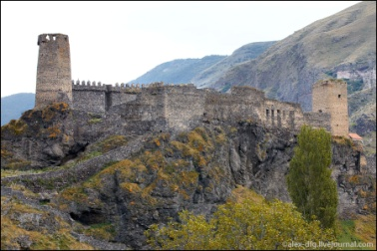
Cave monastery complex of XII-XIII centuries in southern Georgia, Javakheti. An outstanding monument of medieval Georgian architecture. Located in the province of Aspindza region of Samtskhe-Javakheti, in the valley of the Kura River, about 100 km south of Borjomi town, near the village of the same name.
In the center of the monastery is the main temple in honor of the Assumption of the Blessed Virgin. Hall type Temple is blocked of Korobov vault (in girth arches) and is decorated with pilasters on the walls - a unique mural paintings (including images of King George III and Queen Tamar, 1180-ies, George Master.). Most of the historical and artistic values are the frescoes of the Assumption, Ascension, and Decent of the Holy Spirit.
Return and overnight in Tbilisi.

DAY 6 - KAKHETI CRADLE OF WINE
Breakfast in the hotel.
Kakheti is famous not only for its wine, but also with many architectural monuments.
Visit the city of Sighnaghi - City of Love! It is one of Georgia's most beautiful cities. Its attractiveness is largely determined with the age-old architectural heritage and its natural features: The city is located on a hilltop and overlooking at the boundless area of the Alazani Valley and the snow-capped Caucasus Mountains. Sighnaghi was established as a city in the late 18th century, on the territory of the fortress built by King Irakli II and its surroundings. However, archaeological discoveries have shown that the region has played an important role in the country's history from ancient times, during the Paleolithic, Neolithic and Bronze Ages.

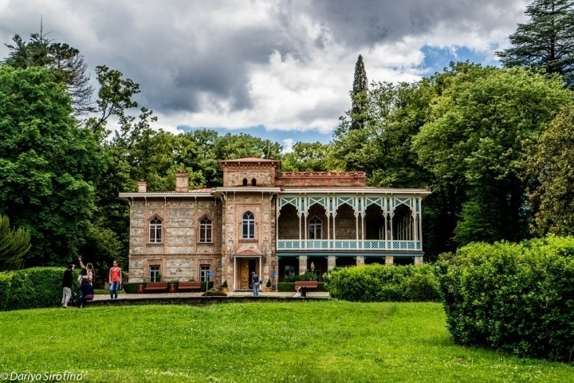
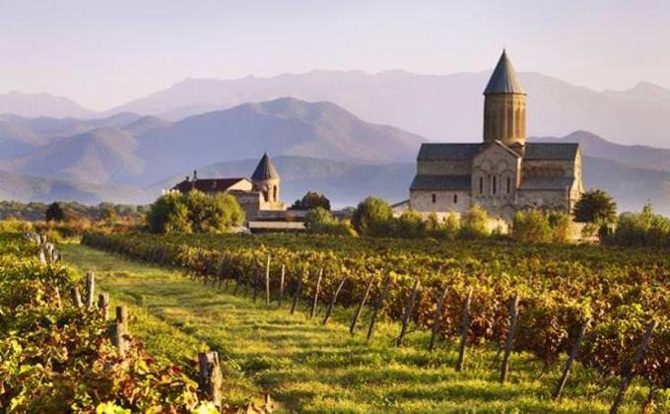

Tsinandali - known viticultural village of Kakheti, the famous wine center, where is the eponymous princes Chavchavadze family estate. Manor, now Chavchavadze House Museum, where is preserved interiors, furniture and personal belongings of the princes. The house-museum is surrounded by a magnificent park with a chapel, in which Alexander Griboyedov married with Princess Nina Chavchavadze. In the same park, Alexander Chavchavadze in 1886 laid the wine cellars, thus deciding to put the traditional handicraft production on an industrial scale
Lunch at Marani Gemini, tasting of Georgian wines. workshops: baking bread, cooking churchkhela, barbecue, Dinner and Overnight in ROYAL BATONI on the shore of Lake Elijah, between the mountains and the river Kvareli Duruji.

DAY 7 - RETURN TO TBILISI
Breakfast in the hotel.
Free day
Airport transfer.

COST OF THE PROGRAM:
 | 2-3 pax | 4-6 pax | 7-9 pax | 10-14 pax | 15-18 pax | 19+ pax
3* | 828 | 738 | 640 | 578 | 545 | 518
4* | 968 | 838 | 734 | 708 | 659 | 638
5* | 1280 | 1180 | 1070 | 1040 | 1018 | 970

The price on:
- Transport the program at comfortable transport;
- Hotel accommodation in Tbilisi in a standard room with breakfast (GRAKO METEKHI HOTEL or KMM);
accommodation at the hotel RIXOS BORJOMI in a standard room with breakfast;
accommodation at the hotel ROYAL BATONI in a standard room with breakfast;
- Drinks in transport: mineral water without gas - 1 bottle of 0.5 liters per person per day;
- Wine tasting and master classes on the program;
- 2 gala dinners according to the program;
- Professional guide services program;
- Entrance tickets to museums and sightseeing according to the program.
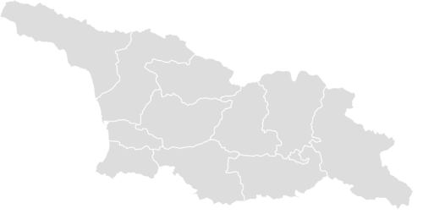
The price does not incl:
- insurance,
- food except. breakfast, guide and driver gratuities, services not mentioned above

TBILISI HOTELS:
METEKHI LINE
MERCURE LD TBILISI
ROOMS TBILISI
KAKHETI HOTEL:
HOTEL ALAZNIS VELI
ROYAL BATONI
LOPOTA LAKE RESORT
BORJOMI HOTEL:
HOTEL FOUR SEASONS
BORJOMI PALACE
CROWN PLAZA BORJOMI

Туроператор «Майвэй Тревел» работает на туристическом рынке с 2011 года
номер в Федеральном Реестре Туроператоров МТ3 017248
_____________________________________________________________________________________

