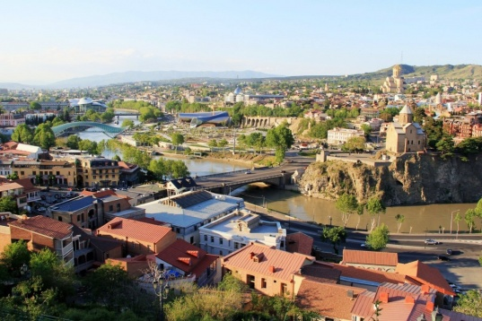
«SVANETI TOUR»
8 nights/ 9 days
Day 1 - Tbilisi
Arrival

Transfer to the hotel in the center of city

Dinner at the national restaurant

Day 2 - Tbilisi-Mtskheta
Breakfast in the hotel.

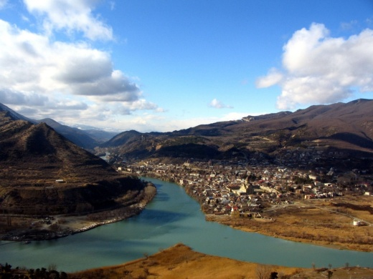
The first half of the day will be devoted to sightseeing tour in Tbilisi-in this unique city, which was revived again. You can see with your eyes ancient and modern Georgian capital.
Metekhi (12 c) Cross-domed church Sulfur baths – ordinary public baths, a feature of which is that the water issue plied from some, where out of the ground, the water is warm and contains a lot of sulfur.

Narikala Fortress - The greatness of this fortress goes to the depth of centuries. It impresses with its high
walls, its towers and impregnable, sitting on Mount Mtatsminda

Sioni Church - historically the main temple of Tbilisi and one of the 2 main in the Georgian Church

Shardeni- Street named after the French Catholic missionary.
Anchiskhati - It belongs to the Georgian Orthodox Church and dates from VII century

The second half of the day we will drive to the town of Mtskheta (30 km from Tbilisi), sightseeing, a visit to the monastery Jvari and Svetitskhoveli Orthodox Cathedral. Return to Tbilisi.

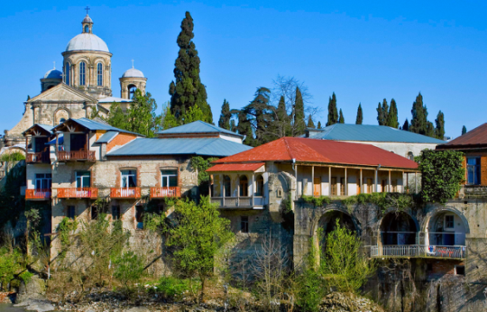
Day 3 – Kutaisi
Breakfast in the hotel.
Kutaisi (old name: Aja, Kutaya, Koytaya, Kotiaion, Kutatisium, part of the Russian Empire Kutaisi) - a town in western Georgia. It is the parliamentary capital of Georgia since 2012.
Visits:
Gelati Monastery - The monastery was founded by King David IV the Builder in 1106 and became his tomb. Collegiate Church was built up in 1125 and another five years was decorated with mosaics, which are considered the best in the whole South Caucasus. At that time the monastery was the seat of the Gelati Academy, whose members are keenly interested in ancient Greek philosophy.

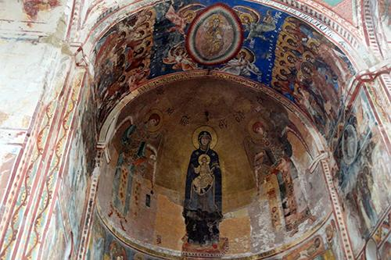
Bagrat Temple - Bagrat Cathedral correctly, sometimes simply "Bagrati". Formally - Church of the Assumption of the Virgin. One of the biggest temples in Georgia and one of the most important in its historical role. Three hundred years stood in a dilapidated condition and in August 2012 was restored, despite the protests of the patriarch and the discontent of individuals. The main attraction of the city of Kutaisi,was maintained even after restoration.

Prometheus Cave - also known as a cave Kumistavi. The limestone massifs of the north a lot of Imereti washed with water holes, but here we have notonly a cave, but a whole network of caves, individual ways and underground halls. The total length of the route - about 22 kilometers, and only one hall is about 17. The caves are very high humidity, there are several underground rivers flow, and there seems to be even underground lakes with their specific flora. In the cave are found a lot of bats, it seems to be of two kinds. These mice can be seen during the tour, even though they try to stay higher from people.
Overnight in Zugdidi.

Day 4 - Zugdidi - Mestia
Breakfast in the hotel.
Palace of Dadiani - Generic Palace Megrelian Princes Dadiani. It is known for its garden, for creation of this garden a ruler Samegrelo Princess Dadiani in the middle of the XIX century has invited eminent European gardeners and wrote out from the European rare species of plants.

Today the garden Dadian - it Zugdidi Botanical Garden. Transfer to Mestia.

Accommodation at the hotel.

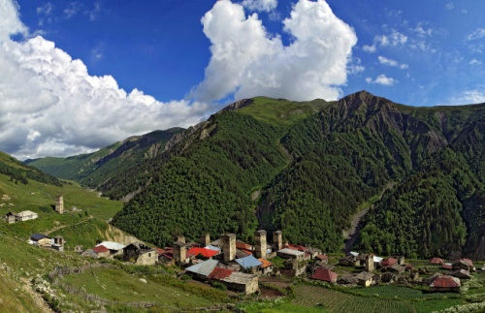
Day 5 – Mestia
Breakfast in the hotel.

Mestia - mountain town, which, like a century ago, is the cultural and economic center of Upper Svaneti. There remained a few dozen medieval towers and churches, which are included in UNESCO World Heritage List. They create a unique cultural landscape that we will study, walking along the old streets and interacting with the locals.
Visit the museum Hergiani - Svan outstanding climber. It contains unique exhibits, and the atmosphere brings in a different era.
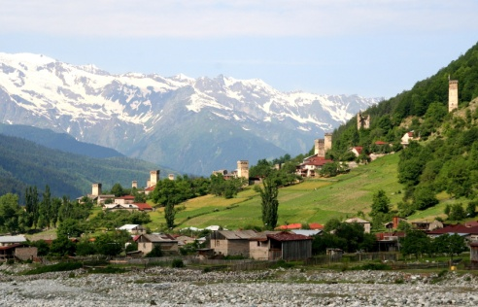
Day 6: Mestia - Ushguli - Mestia

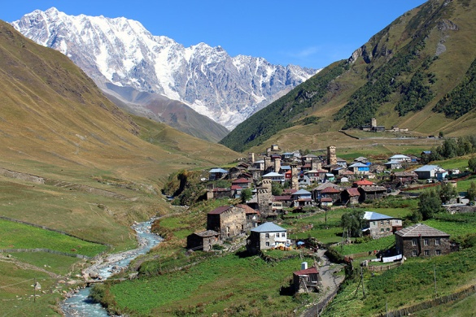
Breakfast in the hotel.
Ushguli - In the morning we will take on SUVs and climb even higher into the mountains. We will see Ushguli, the most high permanent settlement in Europe, it is located at an altitude of 2200 meters. People live here whole year, going down for the winter in the valley.

Thanks to Ushguli architectural ensemble, which is a valuable architectural and historical monument, Upper Svaneti was added to the UNESCO World Heritage List. The village is located on the southern slope Shkhara, one of the highest mountains of the Caucasus (5068m, 5201m according to some sources)
Return to Mestia.

Day 7 - Mestia – Tbilisi
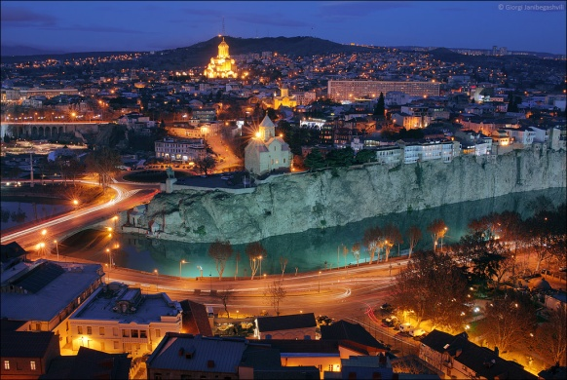
Breakfast in the hotel.
Return to Tbilisi.
FREE TIME

Day 8 – Tbilisi
Breakfast in the hotel.
Free day in Tbilisi.

Day 9 – Tbilisi
Breakfast in the hotel.
Transfer to the airport.

COST OF THE PROGRAM:

The price in a double room for one person
 | 2-3 pax | 4-6 pax | 7-9 pax
Voyager hotel /  hotel Mars Zugdidi /  Hotel Savaneti | 1070 | 980 | 888
Mercure Tbilisi /  Iberia Palace Zugdidi / Banguriani Mestia | 1475 | 1370 | 1250
Hostel Fabrika /  Guest house zugdidi /  Guest house Mestia | 945 | 840 | 740
Included in the price:

-Service Russian speaking guide and the car throughout the tour;

-Transfers;

-Entrance fees;

-Placement on the route / BB;

-1 bottle of water per person per day;

-Dinner at the national restaurant.

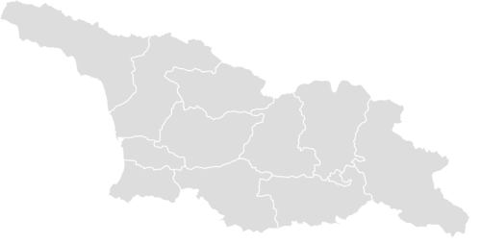

Туроператор «Майвэй Тревел» работает на туристическом рынке с 2011 года
номер в Федеральном Реестре Туроператоров МТ3 017248
_____________________________________________________________________________________

