«Weekend in Georgia»
3 nights/ 4 days
Day 1 - Tbilisi
Arrival
Transfer to the hotel located in the city center. a walk through the old town.
Dinner at the national restaurant.
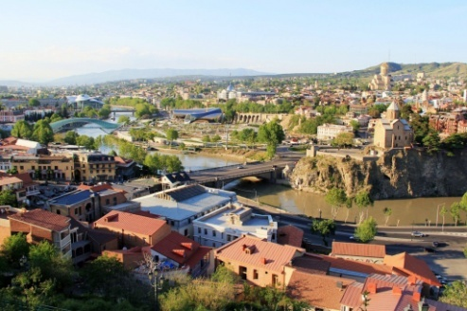 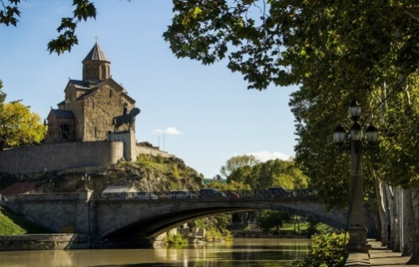 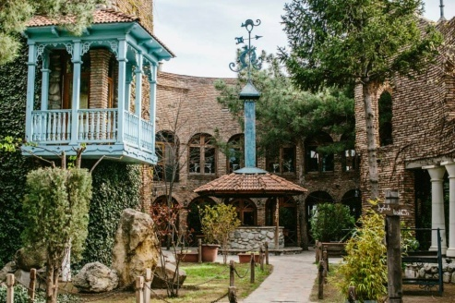
Day 2 – Tbilisi - Mtskheta
Breakfast in the hotel.
The first half of the day, we have devoted a sightseeing tour of Tbilisi - this unique city, revived again. You can see with your own eyes ancient and modern Georgian capital.
Visits:
Metekhi (12th c.) - Cross-domed church
Sulphur baths - ordinary public baths, a feature of which is that the water is supplied from somewhere out of the ground, the water is warm and it contains a lot of sulfur.
Fortress Narikala - The greatness of this fortress goes to the depth of centuries. It impresses with its high walls, its towers and impregnable, sitting on Mount Mtatsminda.
Zion Church - historically the main temple of Tbilisi and one of the 2 main in the Georgian Church; o Shardeni- street named after the French Catholic missionary.
Anchiskhati - It belongs to the Georgian Orthodox Church and dates from the VI century.
The second half of the day we will drive to the town of Mtskheta (30 km from Tbilisi), sightseeing, a visit to the monastery Jvari and Svetitskhoveli Orthodox Cathedral. Return to Tbilisi.
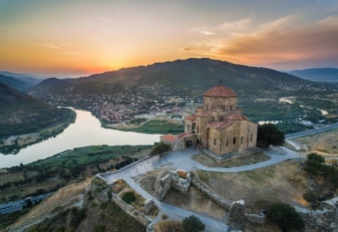 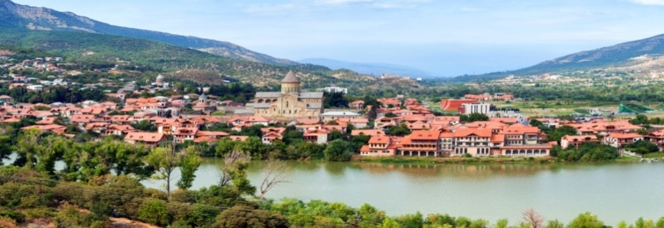
Day 3 – Kakheti
Breakfast in the hotel.
We’ll go with you on a mountain road in Kakheti - home of wine and Georgian mtsvadi (kebabs). Start the day with a visit Sighnaghi, where you can walk around the city of love and enjoy the views of the Alazani Valley. Then we go into the cellar, and of course, this will be tasting of Georgian wine and Chachi. Wah! ... Then settled in the resort Royal Batoni, where we will have the opportunity to enjoy a tasty dinner and a good rest.
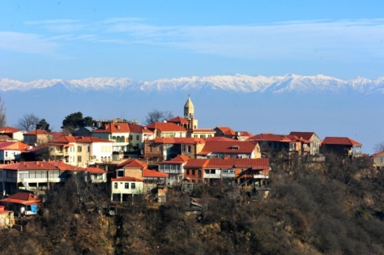 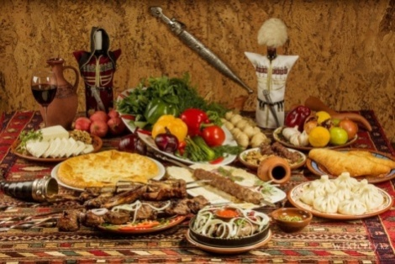 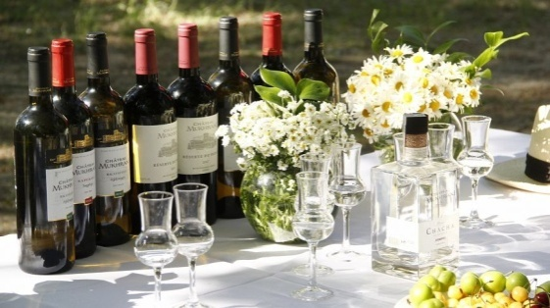
Day 4 - Kaheti – Tbilisi
Breakfast in the hotel.
Start the day with a visit to Tsinandali and the house museum of Alexander Chavchavadze.
Then we return to Tbilisi.
Transfer to the Tbilisi International Airport
COST OF THE PROGRAM:
 | 2-3 pax | 4-6 pax | 7-9 pax | 10-14 pax | 15-18 pax | 19+ pax
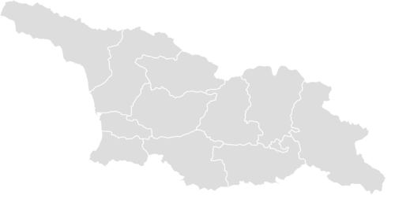  3* | 489 | 388 | 290 | 259 | 239 | 218
4* | 569 | 470 | 380 | 352 | 330 | 318
5* | 655 | 560 | 478 | 448 | 428 | 418
The price includes:
- Service English speaking guide and the car during the tour
- Museum Tickets
- Wine tasting in Kakheti
- Placement on the route / BB
- 1 bottle of water per person per day
Price excludes:
- Single room supplement
- Alcohol drinks

Туроператор «Майвэй Тревел» работает на туристическом рынке с 2011 года
номер в Федеральном Реестре Туроператоров МТ3 017248
_____________________________________________________________________________________

